Visual Inspection on Micro Air Vehicles

Philippe Petit

Studies on Mechatronics
20. Dezember 2010

Advisor: Dr. Friedrich Fraundorfer
Supervisor: Prof. Marc Pollefeys



Index
1. Section 1: Vision Constraints 4
Abstract 4
1.1. Introduction 4
1.2. General 5
1.3. Ground Resolution 8
1.4. Field of View 12
1.5. Maximal Flight Velocity 14
1.6. Electric Hardware 15
1.6.1. Hardware constraint maximal flight velocity 16
1.6.2. Weight aspects 16
1.7. Results 18
2. Section 2: Aircraft Design 19
Summary 20
2.1. Classical fixed wing configuration 21
2.1.1. Flight Velocity for NACA 2412 21
2.1.2. Flight Velocity for HN-1033A 24
2.2. Tailless fixed wing configuration 28
2.3.Blimps 30
2.4. Rotary wing aircrafts 32
2.5. Results 33
Summary and Outlook 34
References 35

1. Section 1: Vision Constraints

Abstract
In this study on Mechatronics, I will analyse the possibility of visual inspection on Micro Air Vehicles. Especially the case of high voltage power line inspection will serve a an case study.
The study is structured in two parts, the first section focuses on the constraints implied by the camera to be installed on the aircraft. The second section then analyses different aircraft forms for their suitability as platforms for visual inspection.
As vision constraints the following dependencies where found: The flight height can be determined to be between 20 metres and 100 metres.
Neither the Field of View nor the flight velocity deliver any constraints for the assumed flight heights, therefore no aircraft form can be excluded a priori.
The aircraft has to be able to carry the payload imposed by the electrical hardware. Two alternatives with a weight of 80 grams respectively 296 grams and different calculation speed are propossed.
Also it will be found that visual inspection on MAVs is cheaper and may achieve higher ground resolutions than commercial available aerial photography
The second section will show, that a fixed wing MAV is best suited for the required testbed for Visual inspection on MAVs. Also a method to find the most efficient cruising speed is proposed.
Outlooks and proposals for future development of visual inspections MAVs are given at the end

1.1. Introduction
Micro Air Vehicles (MAVs) are becoming more and more popular in science, industry and military applications. While being very cheap, they offer a variety of deployment possibilities like posing a stable and easy to handle platform for computer vision, or taking pictures from different angles of buildings. Also local emergency forces are interested in MAVs, as they could get a quick overview of a field of interest, for example a big fire with unknown extend, or a high risk soccer match.
However while all these applications are very interesting, MAVs still do have more potential to unfold in industrial applications e.g. the inspection of overhead power lines, streets, industrial complexes or pipelines. Equipped with the right electronics, the flight and the inspection itself could be performed autonomously and onboard so that no remote human controller would be necessary.
In the following I will concentrate on the example of inspecting an overhead power line with an autonomous MAV.
We want to see disturbances on these power lines like fallen trees, broken isolators or other major structural failures. Therefore we want a certain resolution of the taken picture and we want it to be sufficiently large. I will call the resolution projected on the ground, the “ground resolution” and the physical dimension that is filmed, projected on the ground the “Field of View” (FoV), see Figure 1 for reference.
For safety reasons our MAV can´t fly as low as we want, and we are bound to an upper maximal flight velocity, so that our picture will show no motion-blur.
Possible specifications for a visual inspection systems are therefore:

- Ground resolution
The first factor to specify is the ground resolution, which in this context is defined as the smallest structure visible on photography. For the overhead power line inspection example, a ground resolution of 3 to 5 cm is reasonable. I will always assume in the following that the ground resolution ranges from 3 to 5 cm.
- Field of View
The Field of View is constraint by the size of the structure to be filmed. For the inspection of an overhead power line the entire width of the power line should be visible on the picture. A common high voltage power line in Europe is about 20 metres broad. Which sets our minimal FoV to 20 meters.
- Minimal flight height
Security requires a minimal flight height , which is set to 10 metres.
- Maximum flight velocity
The maximum flight velocity is dependent on the pixel size of the CCD chip and the shutter timer. If we are going too fast, we will receive blurred pictures.
- Carry necessary payload
The payload of the aircraft is the necessary electric hardware to fly autonomously and to take and process pictures.

I will show in the following:
The flight height can be determined to be between 20 metres and 100 metres.
However neither the Field of View nor the flight velocity deliver any constraints for the assumed flight heights. Therefore we can´t exclude any aircraft form a priori.
The aircraft has to have a payload of 80 grams respectively 296 grams plus wiring to support the necessary electronic hardware components for photography and control.

1.2. General
For a first overview of the dependencies of flight height, Field of View and resolution, one can derive some basic equations. In this context we will look at some discrete common used resolutions which are all in a ratio of 4:3. Almost all commercial CCD chips use this ratio and I will assume for all calculations that this ratio is given.

Table 1: Commonly used resolutions
Figure 1: General situation

Basic trigonometry shows that the FoV (in degrees) the flight height (in m) and the resolution are linked by the following Formula:

(1)

h: Flight height
Gr: Ground resolution
resx: Resolution in x-Direction
resy: Resolution in y-Direction
: FoV in Degrees

The FoV is set by the used camera and optics. The following graph shows the flight height in relation to the considered resolution and the FOV.
Plotting the derived formula yields Figure 2, 3 and 4:
Figure 2: The plane represents the necessary flight height for 5cm ground resolution and the given FoV and chip-resolution
Figure 3: Contour-plot of figure 2
Figure 4: Contour-plot of figure 2 with 3 cm ground resolution

1.3. Ground Resolution
The ground resolution is set to 3 cm and 5 cm.
We are modeling the camera as a pinhole camera which is a common approach in Computer Vision: This yields the following equation:
(2)

Whereby “g” is the distance from lens to observed Object, “G” is the size of the observed object “A” is the size of the CCD Sensor and “a” is the distance from lens to CCD chip.
“a” can be replaced by the focal length “f”. We are interested in the ground resolution ““ which replaces “G”. “A” is substituted by the edge length of one pixel, referred to as ”“ . Also “g” corresponds to the height over object “h”:

(3)

The pixel size depends on the used sensor and can be directly calculated with the resolution and the size of the sensor, or it can be looked up in the specifications-sheet of the used CCD-chip.
The calculated pixel sizes are listed in table 3 for some common used resolutions and chip sizes.

Table 2: Sensor sizes
Table 3: Pixel sizes for commonly used resolutions
Nowadays commercially available chips do have pixel sizes between roughly 3μm and 8μm
Nevertheless some pixel size do not exist. For example: To achieve 5 Megapixel on a 1/3” Chip, the table tells us that we have to construct a pixel with a height and width of 1.875μm. This is not possible today. Also a pixel size of 20μm is unrealistic, as it would be very expensive to have a 1” chip with such a low resolution.
Today mostly pixel sizes between roughly 3μm and 8μm are used. Therefore I will focus in the following on these pixel sizes.
Setting the ground resolution to 3cm and 5 cm and plotting all this in Matlab gives us Figure 5, 6, 7 and 8:

Figure 5: The flight height depending on focal length and pixel size. The ground resolution is set to 3 cm.
Figure 6: Contour-plot of Figure 5
Figure 7: The same plot as Figure 5 with a ground resolution of 5 cm
Figure 8: Contourplot of Figure 7
All 3-D Plots like Figure 5 resemble each other for different ground resolutions. However contour plots do contain more information. Therefore I will just show one 3-D plot for each set of plots, to reduce the amount of Pictures.
The plots are very general. For micro-cameras which we plan to use at “Pixhawk” a focal length of more then 7 mm is not practical. Also I will set the lower boundary to 3 mm focal length as the deformation due to the lens system of the picture would be increasingly hard to handle. However, one may of course use big lens systems with a focal length up to 20 mm, but these lens systems are far too heavy to use in a MAV.
Therefore we can read out of the Plots the typical flight height:

- For 3cm ground resolution the flight height lies between roughly 20 and 60 meters.
- For 5cm ground resolution the flight height lies between roughly 40 and 100 meters.

Note that any flight height lower then the one calculated will just result in a higher ground resolution. Thus the plots give the maximum flight height for the specified circumstances.
Also we see that most of these flight height are considerably higher then our minimum safety height of 10 metres.

For your consideration: A system which is currently available for commercial aerial photography is the “”UltraCamXP”, it is deployed on a conventional aircraft. The ground resolution of this system is 1.8 cm at 300 metres flight height and 2.8 cm at 500 metres flying hight. Due to civil laws, airplanes for aerial photography are not allowed to fly below 300 metres. The pixel size is 6 µm at a resolution of 19.6 Megapixels.
As shown ground resolutions of camera systems installed on MAVs are very likely to be under 2 cm. Also the cost for one complete MAV is considerably lower then the deployment of a whole airplane plus the legal cost for the permission of overflying the desired area. Another advantage for the MAV alternative are long term mission like inspection overhead power lines, pipelines or roads. The drawback for an MAV system are however that the “UltraCamXP” system is gyro-stabilised. Therefore the raw pictures of the system can be used. For a MAV this technique would be to heavy. Pictures may therefore need post-processing which would result in a lower ground resolution. Also for the same area to cover, a MAV needs more time.
Anyhow the deployment of an MAV can provide some very interesting advantages over current aerial photography.

1.4. Field of View
For having now set roughly the focal length and the flight height, we have to check whether this agrees with our desired Field of View. This is necessary, as we want to have the entire structure in our Picture.

Figure 9: Plot for the Field of View for different CCD-sensor sizes
Notice: The FoV is here plotted for the Broad side of the Sensor:

Figure 10: Contour-plot of figure 9
Figure 11: Contour-plot of figure 9 with 3mm focal length
The plots show that the Field of View for 3 mm focal length is always bigger then 20 metres in the desired flight height range. For 7 mm focal length however the Field of View is not always bigger, especially when flying very low and using small CCD-chip sizes, the FoV may be smaller, see Figure (8). A detailed analysis with formula (2) might be necessary.
Therefore, only the maximal flight velocity constraint remains to be checked:

1.5. Maximal Flight Velocity
Here we want to determine the maximal velocity at which our picture shows blur effects. In this context we define that blur effects occur as soon as the picture moves more than one pixel in one shutter time. This assumption is conservative, but we try to cover as many cases as possible.
The variable speed is calculated with the same formulas as above. The only difference is that we insert for whereby v denotes the velocity. Inserting all this in into (3).

(4)

After formula (4).

Please note that the height lines denote the flight speed. Therefore we have for the maximal speed

Figure 12: Maximum flight speed in m/s against flight height and pixel size
(bottom left corner) after (4):

This maximum speed for the smallest pixel size is faster then the most MAV´s top Speed. In fact small very agile Quadrocopters can not achieve more then 60 km/h.
If you are using a CCD-ship with a bigger pixel size, which is very likely, the maximum speed increases.
Therefore there hardly exists a constraint in maximum flight speed.

1.6. Electric Hardware
Very important for breach less surveillance of the structure, are connected and overlapping pictures. The bottle neck for this task is the electronic onboard hardware. In the following section I will analyse different hardware configurations, and especially weight aspects.
For this purpose we first have to look at the onboard processing units available. The rate at which pictures can be taken mainly depends on the maximum rate the processing unit can handle a new picture. I will take two single board computers into account:

- The Gumstix Overo coms
- A Intel CORE 2 DUO, carried by a pxCOMex, a COM Express board from Pixhawk.

1.6.1. Hardware constraint maximal flight velocity
The Gumstix Overo single board computer is capable of handling pictures with a refresh rate of roughly 2 Hz., this equals a handling time of 500ms. The CORE 2 DUO however is capable of handling pictures at roughly 30 Hz., this equals a handling time of 33.3ms.
The processing time largely depends on the used vision algorithms, but for a first evaluation, these values are adequately accurate.
With a 50% picture overlap these systems offer a reasonable amount of processing speed reserve.
The y-direction of the sensor points towards flight direction. The maximal permitted processing time for a flight speed of 12 m/s, 3 cm ground resolution and 50% overlap are given in table 4.

Table 4: Maximal processing time for a flight velocity of 12 m/s
As the Gumstix boards maximal refresh rate is 2 Hz, it is able to handle the given circumstances. For 5cm ground resolution we will have higher maximal processing times until 50% overlapping is reached, and therefore no problem with the Gumstix board.
As shown in section 1.3, it is very likely that the ground resolution is higher than 3 cm, what would result in a clear constraint in maximal flight speed.
Suppose that we set the ground resolution to 1 cm respectively 0.5 cm, and still want to maintain 50% overlap of the picture with the same Gumstix onboard processing unit, capable of handling one picture in 500ms (2Hz), then we have the maximal flight speeds listed in table 5.

Table 5:Maximal flight speed in m/s for a calculation time of 500 ms (2HZ).
We can read out of the table for a Y-direction resolution of 480 pixels and 0.5 cm ground resolution the maximal flight speed would be 2.4 m/s(~8.6 km/h), which is very slow. Especially fixed wing aircrafts will have difficulties reaching a speed that slow. High ground resolutions and low Y-direction resolutions can result in clear constraints for the maximal flight speed.
For the CORE 2 DUO of course this poses no problem at all as its Framerate is much higher then that of the Gumstix board.

1.6.2. Weight aspects
The last aspect to consider is the weight aspect.
Also we need certain sensors and other electronics to estimate position, autonomous control of the aircraft and having a downlink for transmission of data.
I don´t take the propulsion system into account, as it is part of the used aircraft, and does not depend on the deployed single board computer system.
Required electronics [4]:
- pxIMU: The Inertia Measurement Unit, needed for state estimation (8g)
- pxAirspeed: A differential Airspeed sensor, needed for estimation of speed. (4g)
- Samsung Sata SSD 256Gb: A hard disc drive for storing pictures and data (37g) (only for the CORE 2 DUO)
- GPS device: For reading out GPS position (~5g)
- 16 Gb USB Device (9g) (only for Overo board)
- Digi XBee Pro: The 2.4 GHZ downlink for radio control and command transfer (4g) (only for the Overoboard, as the pxCOMex has a built in XBee board)
- pxServo: An electronics board for supplying the Pixhawk hardware with power and sending signals to Servos (8g) (only needed for Overo board)

The Overo board itself with support board and camera weights about 30g. The CORE 2 DUO with support board and Camera weights about 220g.
The Overo board does support only one camera. The CORE 2 DUO however can handle several additional cameras each with a weight of 30g.

Summing up:
System | Total Weight
Gumstix Overo | 80 grams
Intel CORE 2 DUO with pxCOMex | 296 grams

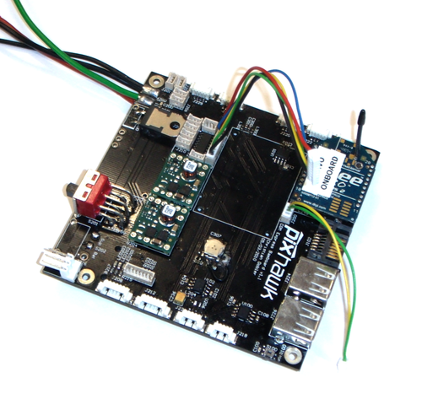Figure 13: The pxCOMex
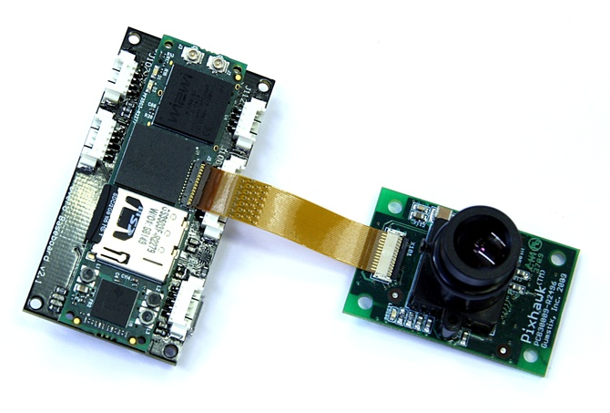Figure 14: The Gumstix Overo board with camera
Of course we missed some minor weight contributors like cables or switches, but basically this should be it.
Another note: The CORE 2 DUO consumes 25 Watt. The Gumstix consumes only 2 Watt. Therefore it might be necessary to install a bigger battery for sufficiently long flight time with the CORE 2 DUO.

1.7. Results
This leaves us with the following conclusion:
The flight height can be determined to be somewhere between 20 metres and 100 metres. Depending on focal length, required ground resolution and used cameras. The best suited height can be determined by using the provided plots or formulas.
However neither the Field of View nor the flight velocity deliver any constraints for the assumed flight heights. If the ground resolution is higher than 3 cm, a detailed analysis for the Gumstix Overo board concerning maximal flight speed has to be done.
However, we can´t exclude any aircraft form a priori.
The aircraft has to have a payload of 80 grams respectively 296 grams plus wiring.
As mentioned before it might be possible that one does not want to fly as high as we calculated in the plots. Therefore the ground resolution might be higher. This final plot shall visualize the resulting ground resolution depending on FoV and flight height and a assumed resolution of 1280x920.

With Formula (1):

Figure 15: Ground resolution in cm for a camera resolution of 1280x1960

2. Section 2: Aircraft Design

As specified in the first section we need our System to fulfill the following properties:

Vision requirements:
- Capable of carrying 80 grams respectively 296 grams payload (+~5% for cabling)
- capable of flying 20 to 100 metres above vision plane
- Operating speed of 12m/s

Also some secondary aspects which are not mandatory, but simplify the deployment of the aircraft are from great interest. These are:

General requirements
- Easy to control with high level of autonomy
- Immune to environmental disturbances like wind, sun or large temperature fluctuations
- Easy to maintain and operate in field
- Cheap

In this section I will analyse different aircraft forms including rotary wing aircrafts, fixed wing aircrafts and lighter than air aircrafts, concerning their suitability for visual inspection. Later on several possible configurations will be proposed for the development of an testbed. This aircraft can then be used to develop and test different controler and camera possibilities. The proposed aircrafts will mostly not represent the cutting edge in efficiency but rather impose a robust choice. This allows us in the following to test different controllers and parameters without having to worry to much about potential damage or total loss during operation of the aircraft.

For the fixed wing aircrafts I will consider two configurations: First, normal configuration with classical fuselage, two wings and a classically shaped empennage. Second, tailess wing aircrafts also called flying wing aircraft such as the "Northrop B-2 Spirit" or the "Dassault Mirage".

For the lighter than air aircrafts the only direct steerable and sufficiently fast aircraft are blimps. These are refered to as non-rigid airships, as they have no internal supporting framework or keel. Airships with keels are in MAV size not available and offers no advantages over blimps in this size.

The rotary wing aircraft chapter will be held very broad, as there exist many construction forms with very different advantages and disadvantages which are not easily to distinguish. Some possible construction forms are: One-main-rotor-one-tail-rotor configuration (referred to as "classical configuration") , quadrocopter configuration, koaxial configuration, tandem configuration, tilt-rotor configuration and intermeshing rotor configuration.

Summary
The following sections basically occupies itself with three different aircraft forms:

- Fixed wing aircrafts
- Rotary aircrafts
- Blimps

The basic advantages and disadvantages are briefly listed in the following:

Fixed wing aircraft:  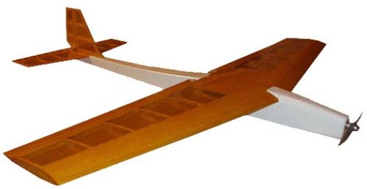  Advantages:  - Cheap  - Easy to control  - Many different models available  - High endurance  Disadvantages  - High minimal flight speed | Rotary wing aircraft:  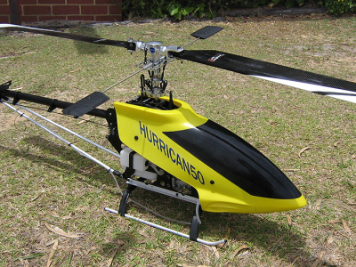  Advantages:  - Vertical take off and landing  - Can hover in midair  Disadvantages  - Low payload  - small endurance | Blimps:  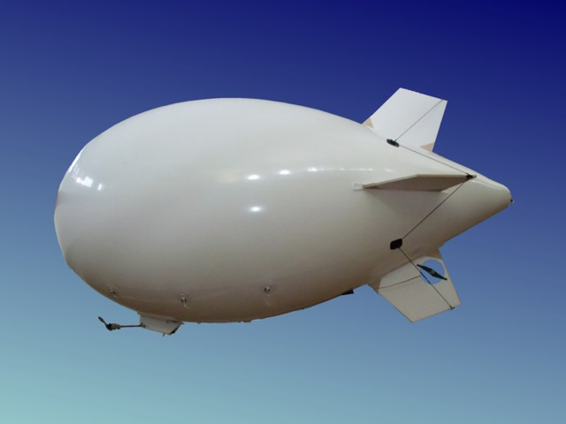  Advantages:  - Large payload  - Can hover in midair  - Very easy to controllers  Disadvantages:  - Difficult to maintain  - Slow

For our testbed the fixed wing is the preferred aircraft.
Also a quick outline for basic aerodynamic calculation concerning most efficient flight speed is given.

2.1. Classical fixed wing configuration

The classical fixed wing configuration offers some very comfortable advantages: It´s fuselage offers enough space for electronics and cameras. Due to the fact that it is widely used for hobby purposes, this configuration is easy to purchase, cheap and a variety of models are available. Control algorithms are widely used, tested and well documented. Also in MAV size it can fly sufficiently low and slowly. Also this aircraft form does not prone to environmental disturbances compared to other MAV configuration.
The payload capacities however are compared to the other configurations average. Also the endurance is not as good as the tailless wing configuration, as the fuselage does not generate any lift, but only contributes to drag. Therefore the efficiency of this aircraft is theoretically lower than the tailless wing configuration. However the commercial available products are very developed, and may therefore impose the better choice after all.

In the following, I will show a method to find the most efficient cruising speed of a fixed wing aircraft, in order to optimize the maximum range. For this calculation some basic aerodynamics have to be reviewed. After this intercourse possible examples for a fixed wing testbed will be presented.

2.1.1. Flight Velocity for NACA 2412
To find the most efficient flight speed one has to look at the aerodynamics of the airplane. I will propose an approach to find this speed in the following.
First of all I want to explain the general idea at the example of one NACA profile [1]. For the example I choose the NACA profile “NACA 2412” which is still quite common though it is 80 years old.
First we have to introduce the so called “Polar curve”, which puts the dimensionless lift and drag coefficients, and some other dimensionless variables into relation to the angle-of-attack, thus the angle at which the airstream is incidenting upon the profile.
The angle of attack is illustrated in Figure 13.

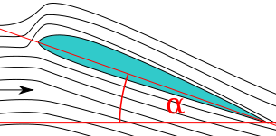Figure 16: Angle of attack upon a wing profile
The NACA polar curves are documentated. For the NACA 2412 we can look into [1], where we will find the following plot.
Figure 17: The Polar curve of the NACA 2412.
The plot is marked on the x-axis as the angle from -8° to +32 degrees. The y-axis is marked with the lift-to-drag ratio, the dimensionless pressure coefficient, and the dimensionless lift respectively the drag coefficient.
You will see the following curves.

: The dimensionless lift coefficient. (Red marked)
; The dimensionless drag coefficient. (Green marked)
: The dimensionless lift-to-drag coefficient: (Blue marked)

The dimensionless lift coefficient represents the force the profile is creating in upward direction. The dimensionless drag coefficient represents the force the profile is opposing to the flight direction. The lift-to-drag ratio is the lift coefficient divided by the drag coefficient.
and are defined as follows:

(5)

(6)

: dimensionless lift coefficient
: dimensionless drag coefficient
: Lifting Force
: Drag Force
: Density of air (1.2 Kg/m³)
A : Surface area of the wing
v : Flight velocity

Looking at the plot we see thatrises with increasing . This can be expected, as it is very intuitive that the upward force is getting bigger the more the foil is tilted. The same holds true for .
The most interesting part however is the dimensionless lift-to-drag coefficient, which shows at which angle we get the most lift for the lowest drag. In other words it denotes the point at which the profile reaches its maximum efficiency, in the plot above situated at roughly 3°. Therefore in cruise flight, this angle will achieve the lowest fuel consumption.
Reading out of the plot we can see that at 3°. With the lift coefficient formula (5) and the known parameters and A we can now calculate the flight velocity at which the airplane flies most efficiently. I will not execute this calculation here, as it is trivial.

All these plots are done at specific “Reynolds-numbers”. The Reynolds-number is a very important dimensionless number to characterise the flow. Going to deep into this topic of fluid dynamics would exceed the boundaries of this study.
However note that the polar curve from Figure 14 was taken at a Reynolds-number of 3 250 000. A typical Reynolds-number for large aircrafts.
For illustration purpose, I also want to show the pressure profile over the NACA 2412 at an angle of 0° calculated with the free programm X-foil [2]:

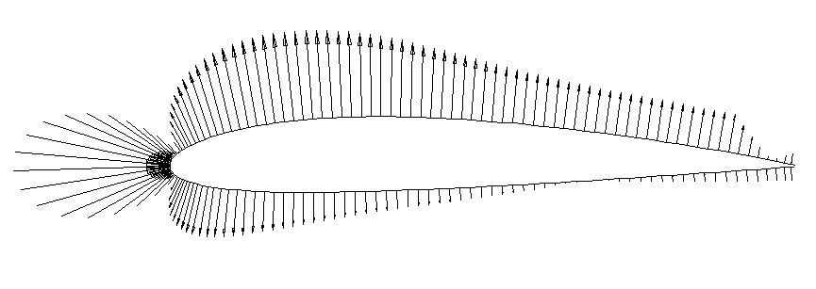Figure 18: Pressure profile of NACA 2412 visualised with pressure vectors.

2.1.2. Flight Velocity for HN-1033A
Now we want to do the same Calculation for the profile the “Multiplex Merlin” actually uses. Unfortunately the manufacturer does not want to publish the used profile. I will therefore do the analysis for a wing profile which is quite commonly for small gliders like the “Merlin”. Of course this is only an approximation.
The wing profile I analyse is the “HN-1033A”. A picture is below.
Figure 19: The HN-1033A profile

For our wing the Reynolds-number calculates as follows:

(7)

u : Flight speed
l : Characteristic length. In our case it is the length of the wing.
: Cinematic viscosity of air (15*10^-6 m²/s)

The designer of this profile provided us a numerical simulation of this foil. It is not 100% accurate and it is for the Reynolds-number 115 000. But the curves do not change much with different Reynolds-numbers.
Figure 20: Polar Curve of HN-1033A
The maximum of the lift-to-drag coefficient is at 7°, the dimensionless lift coefficient at this angle is:

= 0.7674
= 0.415 Kg * 9.81 m/s² (Weight of the aircraft with electronics)

This allows the calculation of the most efficient cruising speed with (5):

The airplanes mentioned here can only be a proposition, as it is impossible to review all existing model airplanes in this size.

The first aircraft I want to propose is the "Multiplex Merlin". It is a small electrical powered model airplane capable of carrying the small Overo onboard computer. For our purpose it is necessary to equip it with an larger battery of roughly 1000 mAh.

Multiplex Merlin
Wingspan | 783 mm
Overall length | 598 mm
Weight without\with electronics | ~ 325g\415g
Surface area of wings | 11.3 dm²
Stress per wing area | 28.76 g/dm² \ 36.73 g/dm²
Maximal speed | ~70 km/h
Projected Operating speed | ~32 km/h
Projected Flight time | ~30 min
Maximal travel distance | 16 km
Profile (Approximation) | HN-1033A

Wingspan: 783 mm
Overall length: 598 mm
Weight with/without electronics: ~ 325g/415 g
Surface area of the wing: 11,3 dm²
Stress per wingarea: 28.76 g/dm² / 36.73g/dm²

The model is available at [8].
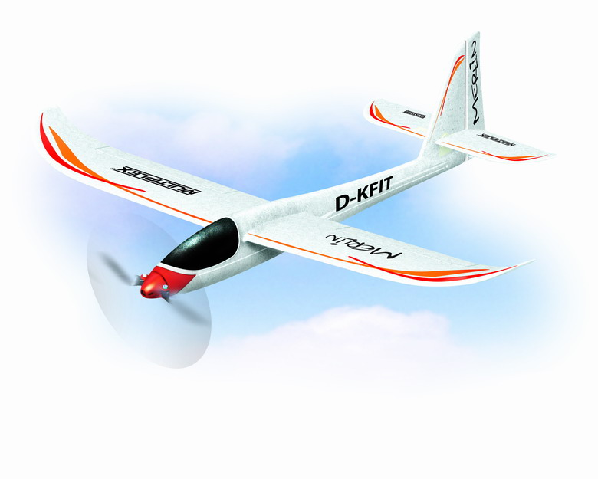Figure 21: The Multiplex Merlin
An example of a robust model which is capable of carrying the large and heavy CORE 2 DUO is the “Multiplex Easy Glider PRO” built out of cheap and robust Elapor, a Styropor-like foam. This model has to be equipped with a larger battery, as the CORE 2 DUO power consumption with ~30 Watt is very high.
The average flying time with motor is approximately around 30 Minutes. Therefore calculation shows that additionally ~2000mAH are needed to supply the CORE 2 DUO board. I recommend a Battery of around 4500 mAH.
Again as for the “Multiplex Merlin” the manufacturer didn´t provide the used wing profile, therefore I again calculate the characteristics with the HN-1033A.

Multiplex Easy Glider Pro
Wingspan | 1800 mm
Overall length | 1130 mm
Weight without\with electronics | ~ 1000g\1350g
Surface area of wings | 41.6 dm²
Stress per wing area | 24.03 g/dm² \ 32.45 g/dm²
Maximal speed
Projected Operating speed | 30 km/h
Projected Flight time | ~30 min
Maximal travel distance | 15 km
Profile (approximation) | HN-1033A

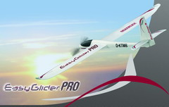Figure 22:Multiplex Easy Glider Pro

2.2. Tailless fixed wing configuration
The tailless fixed wing configuration can be a very tempting design for long endurance autonomous flight. It possesses no fuselage which would induce unnecessary drag and yields us therefore high efficiency. Some flight characteristics are very desirable, for example in curves they are more stable then conventional aircrafts. The big internal volume of such a flying wing provides enough space for large electronic devices like the CORE 2 DUO. Also the payload ratio can be higher at the same size as normal configuration. The surface area of these aircrafts is big, so that for example solar cells for inflight energy retrieval could be installed. These solar cells could even be integrated in the design, as the load per surface of this configuration is typically very small. This would allow us to construct the wings in such a manner that the solar cells itself becomes the wing. All this would result in an extremely lightweight aircraft with the possibility to fly even over night. Of course this would be a huge advantage! Imagine an aircraft which could theoretically stay in the air as long as you want! This would be the ultimate goal for visual inspection, as we could carry out extremely extended missions like inspecting structures with several hundreds of kilometres length.
However this design also poses some big disadvantages: The small inertia around the pitch axis and the lacking of an empennage often induces a oscillation around the pitch axis. For MAVs this oscillation is becoming even worse, as the inertia is even lower, what would result in sensor noise for the IMU sensor, which might be quite hard to control. Flight-characteristics are often worse than for conventional aircrafts as they suffer in the attempt to make the aircraft stable and steerable, and the lacking empennage results in less yaw-direction stability. Top speed is typically lower than in normal configuration [3].
This all leaves us with a rather down-to-earth conclusion. The tailless wing aircraft is not very suited for a testbed visual inspection aircraft. For a state-of-the-art project it could be worth developing an airplane in tailless wing configuration, but this might be more challenging.
If however one is interested in testing such an aircraft anyway I propose to take the ”Multiplex Xeno” as it is relatively light and built out of foam, therefore very crash resistant.

Multiplex Xeno
Wingspan | 1245 mm
Overall length | na
Weight without\with electronics | ~690g\780g
Surface area of wings | 32 dm²
Stress per wing area | 21.6 g/dm² \ 24,38 g/dm²
Maximal speed | -to be added-
Projected Operating speed | -to be added-
Projected Flight time | -to be added-
Maximal travel distance | -to be added-
Profile

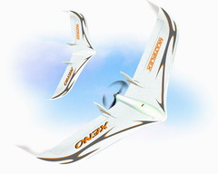Figure 23:The Multiplex Xeno

2.3.Blimps
About MAV blimps I found surprisingly few material.
Anyway the advantages are clear: Blimps provide large payload capacity and much volume for installing big hardware. The main advantage of blimps are their capability to stop and hover endlessly over one spot. Also they are easy to control due to the stability of their static lift.

The drawback are however that they are very big, infact Blimps with a length of 5 metres hardly count as an MAV. They can´t be easily deployed in the field because of their need for helium to generate the static lift. The helium can also be a problem if exhibited to sun irradiation or large temperature fluctuations and they prone easily to wind.

I will here present two commercial product from the manufacturer “Minizepp”. One is the “Minizepp 4000 indoor” and the second is the “Minizepp 5000 outdoor”. Both of them are the smallest systems available for indoor respectively outdoor use. Interesting enough both of them are capable of carrying 400 grams of payload which is enough for the Overo and the CORE 2 DUO even with an separate energy supply. The data sheet is the following:

Minizepp 5000 outdoor
Length | 5 m
Diameter | 1.5 m
Max height | 1.8 m
Max width | 1.7 m
Volume | 7 m³
Power | 2 x 800 Watt
Flight time | 0.45 hours
Max speed | 11.12 m/s (40 km/h)
Payload | 400 grams
Wind limit | 6.2 m/s
Maximum Travel Distance | 18 km

Minizepp 4000 indoor
Length | 4 metres
Diameter | 1.4 m
Max height | 1.6 m
Max width | 1.5 m
Volume | 5 m³
Power | 2 x 200 Watt
Flight time | 0.45 hours
Max speed | 8.33 m/s (30km/h)
Payload | 0.5 Kg
Wind limit | - (not available as it is intentioned for indoor use, but naturally lower than the maximal flying speed of 8m/s)
Maximum travel distance | 13.5 km

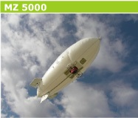Figure 24: The Mz 5000 outdoor
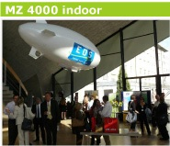Figure 25: The Mz 4000 indoor

2.4. Rotary wing aircrafts
Rotary Wing aircrafts posses some practical advantages for computer vision flight. With the right construction form, they can carry relatively big loads while the physical dimension remains low. Rotary wing aircrafts are nevertheless quite agile. The biggest advantage however is their ability to move in every direction regardless of their yaw axis. This implies also that rotary wing aircrafts can stop and hover in midair, which makes them very desirable for certain applications in Computer Vision. For further detail regard the following paper:[4]. These abilities make them quite popular for computer vision applications.
Yet they also have some disadvantages which disqualifies them for use in visual inspection. Their payload capacity is low compared to overall weight. Also helicopters are quite inefficient because all rotary wing aircrafts have to continuously generate lift in flight, thus flight time is very low. Control of some rotary wing aircrafts like the one-main-rotor-one-tail-rotor configuration or the coaxial configuration can be quite messy due to coupled steering inputs. These problems typically arise when a helicopter is using cyclic blade control, therefore only the construction form “Quadrocopter” does not impose any big problems regarding control. Infact this design form is very well documented and quite wide spread. The Pixhawk Team [4] for example initially used a koaxial helicopter for the participation at the IMAV 09. Eventually the team then realised that this construction form is too hard to control and also does not provide enough space and payload capacity for their needs.
To sum all the different advantages and disadvantages of different rotary wing building forms up, I provide the following table following this paper:[5].
Every building form receives notes for its characteristics ranging from 1 to 8, wherby 8 is the best grade. Also every value is weighted regarding how important the respective characteristic is.

For our purpose the quadrocopter imposes the best choice.

2.5. Results
Thus every aircraft form has its specific advantages and disadvantages. To choose a good aircraft form for the upcoming task of building a testbed, it might be helpful to draw a Criteria Matrix.
Please note, environmental prone denotes how much the regarded aircraft prones to environmental disturbances. Availability gives a value for how good the aircraft form is available on the commercial market.

Therefore we can say that the conventional aircraft is the best suited choice for a MAV testbed for Visual Inspection.
However consider the following:

Results and Outlook
Summing up we can say the following:
Of all evaluated aircraft forms the fixed wing standard configuration is best suited for the planned visual inspection testbed.
The “Multiplex Merlin” is capable of carrying enough payload to support the Gumstix Overo board with camera and all needed electronics.
The “Multiplex Easy Glider pro” is capable of carrying enough payload to support the Intel CORE 2 DUO with pxCOMex board and all needed electronics.
One of these two propositions may now be choosen.
Concerning vision, we can say that the flight height lies somewhere between 20 and 100 metres depending on focal length required ground resolution and used cameras. The best suited height can be determinded by using the provided plots or formulas.
Neither the Field of View nor the flight velocity delivers constraints. If one is using the Gumstix Overo board with a high ground resolution detailed analysis concerning flight speed has to be done.

For an eventual development of an commercial product, it might be very interesting to review other aircraft forms. Especially the tailles fixed wing configuration can be very rewarding. A good starting point may be the hobby sector. These people already developed high efficiency aircrafts with complex wing geometry and many many testing hours spent. A good example is the so called “F5B” competition. This competition focuses long time efficiency flight at very high speed. Both conventional fixed wing and tailles fixed wing aircrafts are deployed. The airplanes deployed there are much to fast for visual inspection purpose but it might be a good starting point. For further reading I propose [6] and as an example [7]. If at the end one succeds in creating an high efficiency aircraft it could very well be equipped with solar cells. Pushing this to the edge aircraft would become able to fly all night and all night long nonstop. Therefore the mission time could rise to several days flight time. Inspections of several hundred kilometres length would be in reach.

References
- Jacobs, E.N., Ward, K.E., Pinkerton, R.M.: The characteristics of 78 Related airfoil sections from tests in the variable-density wind tunnel (1933)
- Drela, M.: X-foil subsonic airfoil debelopment system. http://raphael.mit.edu/xfoil (2004)
- Nickel, K., Wohlfahrt M.: Tailless aircraft : in theory and practice
- Meier, L., Tansken, P., Fraundorfer, F., Pollefeys, M.,: Pixhawk: A System for Autonomous Flight using Onboard Computer Vision
- Schafroth, D., Bouabdallah, Bermes, C., Siegwart, R.:From the Test Benches to the First Prototype of the muFly Micro Helicopters
- http://www.f5b.de/
- http://www.franz-josef-ney-online.de/
- http://www.multiplex-rc.de

